DETAILSOFFACULTYMEMBERS

 | NAME: | Dr. SHAIK MOHAMMED KHASIM
 | DESIGNATION: | DIRECTOR
 | DATEOFBIRTH | 20-09-1985
 | EDUCATIONALQUALIFICATION | Ph.D–COLONCANCER
 | AREAOFSPECIALIZATION | PHARMACOLOGY
 | WORK/TEACHINGEXPERIENCE: | 15 Years
 | NUMBEROFRESEARCHPUBLICATION: | 28
 | NUMBEROFCONFERENCESATTENDED: | 08

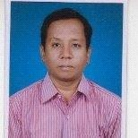 | NAME: | Dr. RAAVI SRIDHAR BABU
 | DESIGNATION: | PRINCIPAL&PROFESSOR
 | DATEOFBIRTH | 10-09-1977
 | EDUCATIONALQUALIFICATION | B.PHARMACY,M.PHARMACY&Ph.D,
 | AREAOFSPECIALIZATION | PHARMACEUTICS
 | WORK/TEACHINGEXPERIENCE: | 17 Years
 | NUMBEROFRESEARCHPUBLICATION: | 30
 | NUMBEROFCONFERENCESATTENDED: | 05

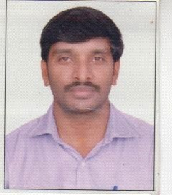 | NAME: | Dr. D.V. KISHORE
 | DESIGNATION: | VICE PRINCIPAL & PROFESSOR
 | DATEOFBIRTH | 31-01-1980
 | EDUCATIONALQUALIFICATION | B.PHARMACY,M.PHARMACY&Ph.D,
 | AREAOFSPECIALIZATION | PHARMACOLOGY
 | WORK/TEACHINGEXPERIENCE: | 18 Years
 | NUMBEROFRESEARCHPUBLICATION: | 35
 | NUMBEROFCONFERENCESATTENDED: | 12

 | NAME: | Dr. KUNDA PAVAN KUMAR
 | DESIGNATION: | PROFESSOR
 | DATEOFBIRTH | 24-07-1977
 | EDUCATIONALQUALIFICATION | B.PHARMACY,M.PHARMACY&Ph.D,
 | AREAOFSPECIALIZATION | PHARMACEUTICALCHEMISTRY
 | WORK/TEACHINGEXPERIENCE: | 19 Years
 | NUMBEROFRESEARCHPUBLICATION: | 45
 | NUMBEROFCONFERENCESATTENDED: | 15

 | NAME: | Mrs. HABEEB UNNISA
 | DESIGNATION: | ASSOCIATE PROFESSOR
 | DATEOFBIRTH | 20-08-1974
 | EDUCATIONALQUALIFICATION | M.Sc,
 | AREAOFSPECIALIZATION | BOTANY
 | WORK/TEACHINGEXPERIENCE: | 24Years
 | NUMBEROFRESEARCHPUBLICATION: | 0
 | NUMBEROFCONFERENCESATTENDED: | 0

 | NAME: | Dr. AMJAD PASHA
 | DESIGNATION: | PROFESSOR
 | DATEOFBIRTH | 14-04-1983
 | EDUCATIONALQUALIFICATION | B.PHARMACY,M.PHARMACY&Ph.D,
 | AREAOFSPECIALIZATION | PHARMACEUTICALCHEMISTRY
 | WORK/TEACHINGEXPERIENCE: | 17 Years
 | NUMBEROFRESEARCHPUBLICATION: | 08
 | NUMBEROFCONFERENCESATTENDED: | 03

 | NAME: | Dr. PARWEZ ALAM
 | DESIGNATION: | PROFESSOR
 | DATEOFBIRTH | 10-01-1981
 | EDUCATIONALQUALIFICATION | B.PHARMACY,M.PHARMACY&Ph.D,
 | AREAOFSPECIALIZATION | PHARMACOGNOSY
 | WORK/TEACHINGEXPERIENCE: | 15 Years
 | NUMBEROFRESEARCHPUBLICATION: | 30
 | NUMBEROFCONFERENCESATTENDED: | 10

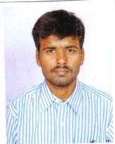 | NAME: | Dr. M. HARISH REDDY
 | DESIGNATION: | PROFESSOR
 | DATEOFBIRTH | 15-08-1978
 | EDUCATIONALQUALIFICATION | B.PHARMACY,M.PHARMACY&Ph.D,
 | AREAOFSPECIALIZATION | PHARMACEUTICS
 | WORK/TEACHINGEXPERIENCE: | 18 Years
 | NUMBEROFRESEARCHPUBLICATION: | 10
 | NUMBEROFCONFERENCESATTENDED: | 06

 | NAME: | Dr.MD AVEZ ALI
 | DESIGNATION: | PROFESSOR
 | DATEOFBIRTH | 20-10-1986
 | EDUCATIONALQUALIFICATION | B.PHARMACY,PHARM–D(P.B.),Ph.D,
 | AREAOFSPECIALIZATION | PHARMACYPRACTICE&CLINICAL  PHARMACY
 | WORK/TEACHINGEXPERIENCE: | 12 Years
 | NUMBEROFRESEARCHPUBLICATION: | 06
 | NUMBEROFCONFERENCESATTENDED: | 15

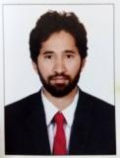 | NAME: | Dr. SYED HAFEEZ AHMED
 | DESIGNATION: | PROFESSOR
 | DATEOFBIRTH | 20-06-1989
 | EDUCATIONALQUALIFICATION | B.PHARMACY,M.PHARMACY, Ph.D.
 | AREAOFSPECIALIZATION | PHARMACEUTICALANALYSIS
 | WORK/TEACHINGEXPERIENCE: | 11.3Years
 | NUMBEROFRESEARCHPUBLICATION: | 10
 | NUMBEROFCONFERENCESATTENDED: | 08

 | NAME: | Dr.MOHD FASI AHMED
 | DESIGNATION: | PROFESSOR
 | DATEOFBIRTH | 20-09-1990
 | EDUCATIONALQUALIFICATION | B.PHARMACY,M.PHARMACY,Ph.D.
 | AREAOFSPECIALIZATION | PHARMACEUTICALMANAGEMENTAND  REGULATORYAFFAIRS
 | WORK/TEACHINGEXPERIENCE: | 11 Years
 | NUMBEROFRESEARCHPUBLICATION: | 01
 | NUMBEROFCONFERENCESATTENDED: | 03

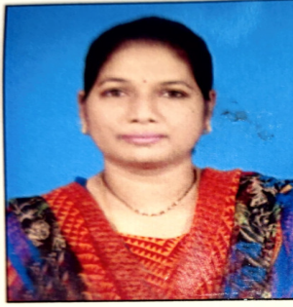 | NAME: | Dr .ARCHANA RAO
 | DESIGNATION: | PROFESSOR
 | DATEOFBIRTH | 21-04-1983
 | EDUCATIONALQUALIFICATION | B.PHARMACY,M.PHARMACY,Ph.D.
 | AREAOFSPECIALIZATION | PHARMACEUICALCHEMISTRY
 | WORK/TEACHINGEXPERIENCE: | 13 Years
 | NUMBEROFRESEARCHPUBLICATION: | 02
 | NUMBEROFCONFERENCESATTENDED: | 04

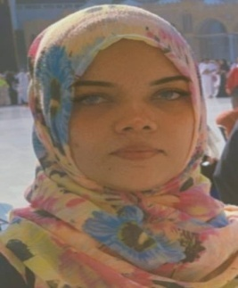 | NAME: | Ms. ADIB AFREEN
 | DESIGNATION: | ASSOCIATE PROFESSOR
 | DATEOFBIRTH | 11/02/1988
 | EDUCATIONALQUALIFICATION | B.PHARMACY,M.PHARMACY
 | AREAOFSPECIALIZATION | PHARMACOLOGY
 | WORK/TEACHING EXPERIENCE: | 11
 | NUMBEROFRESEARCHPUBLICATION: | 15
 | NUMBEROFCONFERENCESATTENDED: | 5

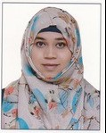 | NAME: | Ms .SYEDA MAIMOONA FARHEEN
 | DESIGNATION: | ASSOCIATE PROFESSOR
 | DATEOFBIRTH | 04/01/1992
 | EDUCATIONALQUALIFICATION | B.PHARMACY,M.PHARMACY,
 | AREAOFSPECIALIZATION | PHARMACOLOGY
 | WORK/TEACHINGEXPERIENCE: | 7 Year
 | NUMBEROFRESEARCHPUBLICATION: | 1
 | NUMBEROFCONFERENCESATTENDED: | 4

 | NAME: | Mr. MOHD ABDULTAWWAB
 | DESIGNATION: | ASSOCIATE PROFESSOR
 | DATEOFBIRTH | 11-12-1987
 | EDUCATIONALQUALIFICATION | B.PHARMACY,M.PHARMACY,
 | AREAOFSPECIALIZATION | PHARMACOLOGY
 | WORK/TEACHINGEXPERIENCE: | 9 Years
 | NUMBEROFRESEARCHPUBLICATION: | 03
 | NUMBEROFCONFERENCESATTENDED: | 02

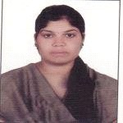 | NAME: | Ms. AMBALA RAMA DEVI
 | DESIGNATION: | ASSOCIATE PROFESSOR
 | DATEOFBIRTH | 26-10-1992
 | EDUCATIONALQUALIFICATION | B.PHARMACY,M.PHARMACY,
 | AREAOFSPECIALIZATION | PHARMACOGNOSY
 | WORK/TEACHINGEXPERIENCE: | 5 Years
 | NUMBEROFRESEARCHPUBLICATION: | 01
 | NUMBEROFCONFERENCESATTENDED: | 03

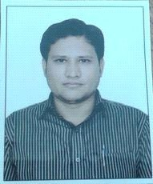 | NAME: | Mr. MOHAMMED AIJAZUDDIN
 | DESIGNATION: | ASSOCIATE PROFESSOR
 | DATEOFBIRTH | 25-08-1985
 | EDUCATIONALQUALIFICATION | B.PHARMACY,M.PHARMACY,
 | AREAOFSPECIALIZATION | PHARMACEUTICALANALYSIS&QUALITY  ASSURANCE
 | WORK/TEACHINGEXPERIENCE: | 11 Years
 | NUMBEROFRESEARCHPUBLICATION: | 02
 | NUMBEROFCONFERENCESATTENDED: | 01

 | NAME: | Dr. MUJAHED PASHA
 | DESIGNATION: | ASSOCIATE PROFESSOR
 | DATEOFBIRTH | 14/07/1991
 | EDUCATIONALQUALIFICATION | B.PHARMACY,M.PHARMACY,Ph.D.
 | AREAOFSPECIALIZATION | PHARMACEUTICALANALYSIS
 | WORK/TEACHINGEXPERIENCE: | 06 Years
 | NUMBEROFRESEARCHPUBLICATION: | 02
 | NUMBEROFCONFERENCESATTENDED: | 04

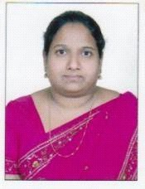 | NAME: | Ms. SANAM HEPSIBA BUELA
 | DESIGNATION: | ASSOCIATE PROFESSOR
 | DATEOFBIRTH | 06-07-1978
 | EDUCATIONALQUALIFICATION | B.PHARMACY,M.PHARMACY,
 | AREAOFSPECIALIZATION | PHARMACEUTICALANALYSIS
 | WORK/TEACHINGEXPERIENCE: | 10 Years
 | NUMBEROFRESEARCHPUBLICATION: | 04
 | NUMBEROFCONFERENCESATTENDED: | 04

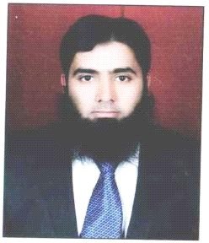 | NAME: | Dr. SYED ASEEM
 | DESIGNATION: | ASSOCIATE PROFESSOR
 | DATEOFBIRTH | 23-10-1989
 | EDUCATIONALQUALIFICATION | PHARM–D,Ph.D,
 | AREAOFSPECIALIZATION | PHARMACYPRACTICE
 | WORK/TEACHINGEXPERIENCE: | 10 Years
 | NUMBEROFRESEARCHPUBLICATION: | 04
 | NUMBEROFCONFERENCESATTENDED: | 05

 | NAME: | Dr. ISRARUDDIN MOHAMMED
 | DESIGNATION: | ASSOCIATE PROFESSOR
 | DATEOFBIRTH | 10-09-1992
 | EDUCATIONALQUALIFICATION | PHARM–D
 | AREAOFSPECIALIZATION | PHARMACYPRACTICE
 | WORK/TEACHINGEXPERIENCE: | 06 Years
 | NUMBEROFRESEARCHPUBLICATION: | 02
 | NUMBEROFCONFERENCESATTENDED: | 03

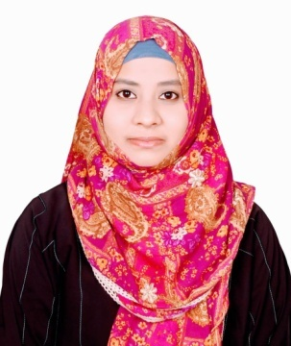 | NAME: | Ms. RIYAZ FATIMA
 | DESIGNATION: | ASSOCIATE PROFESSOR
 | DATEOFBIRTH | 18-10-1990
 | EDUCATIONALQUALIFICATION | B.PHARMACY,M.PHARMACY,
 | AREAOFSPECIALIZATION | PHARMACEUTICALANALYSIS
 | WORK/TEACHINGEXPERIENCE: | 10 Years
 | NUMBEROFRESEARCHPUBLICATION: | 03
 | NUMBEROFCONFERENCESATTENDED: | 05

 | NAME: | Ms. NILOUFER TASNIM KHAZI
 | DESIGNATION: | ASSOCIATE PROFESSOR
 | DATEOFBIRTH | 25/03/1988
 | EDUCATIONALQUALIFICATION | B.PHARMACY,M.PHARMACY
 | AREAOFSPECIALIZATION | PHARMACEUTICALANALYSIS
 | WORK/TEACHINGEXPERIENCE: | 09 Years
 | NUMBEROFRESEARCHPUBLICATION: | 02
 | NUMBEROFCONFERENCESATTENDED: | 02

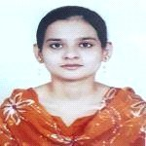 | NAME: | Dr. NOORUNNISA BEGUM
 | DESIGNATION: | ASSOCIATE PROFESSOR
 | DATEOFBIRTH | 30/03/1993
 | EDUCATIONALQUALIFICATION | B.PHARMACY,PHARM-D(P.B.)
 | AREAOFSPECIALIZATION | PHARMACYPRACTICE
 | WORK/TEACHINGEXPERIENCE: | 07 Years
 | NUMBEROFRESEARCHPUBLICATION: | 05
 | NUMBEROFCONFERENCESATTENDED: | 03

 | NAME: | Mr. SYED AZHER HUSSAIN
 | DESIGNATION: | ASSOCIATE PROFESSOR
 | DATEOFBIRTH | 20-11-1982
 | EDUCATIONALQUALIFICATION | B.PHARMACY,M.PHARMACY,
 | AREAOFSPECIALIZATION | PHARMACOLOGY
 | WORK/TEACHINGEXPERIENCE: | 04 Years
 | NUMBEROFRESEARCHPUBLICATION: | 01
 | NUMBEROFCONFERENCESATTENDED: | 03

 | NAME: | Mr. MOHAMMED AFROZUDDIN
 | DESIGNATION: | ASSOCIATE PROFESSOR
 | DATEOFBIRTH | 08-07-1991
 | EDUCATIONALQUALIFICATION | B.PHARMACY,M.PHARMACY,
 | AREAOFSPECIALIZATION | PHARMACEUTICALANALYSIS
 | WORK/TEACHINGEXPERIENCE: | 08 Years
 | NUMBEROFRESEARCHPUBLICATION: | 02
 | NUMBEROFCONFERENCESATTENDED: | 04

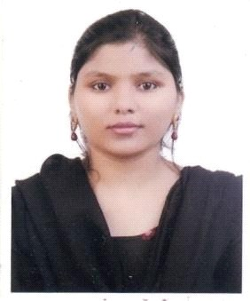 | NAME: | Mrs. AYESHA TABASSUM
 | DESIGNATION: | ASSOCIATE PROFESSOR
 | DATE OF BIRTH | 24-06-1991
 | EDUCATIONAL QUALIFICATION | B.PHARMACY,M.PHARMACY,
 | AREA OF SPECIALIZATION | PHARMACEUTICS
 | WORK/TEACHING EXPERIENCE: | 08 Years
 | NUMBER OF RESEARCH PUBLICATION: | 01
 | NUMBER OF CONFERENCES ATTENDED: | 04

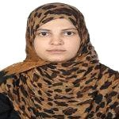 |  | NAME: |  | Ms. RUBEENA KAUSER
 |  | DESIGNATION: |  | ASSOCIATE PROFESSOR
 |  | DATE OF BIRTH |  | 29/06/1988
 |  | EDUCATIONAL QUALIFICATION |  | B.PHARMACY,M.PHARMACY,
 |  | AREA OF SPECIALIZATION |  | PHARMACOLOGY
 |  | WORK/TEACHING EXPERIENCE: |  | 06 Years
 |  | NUMBER OF RESEARCH PUBLICATION: |  | 03
 |  | NUMBER OF CONFERENCES ATTENDED: |  | 05
 | NAME: |  | Ms. BUTHUL FATIMA
 | DESIGNATION: |  | ASSOCIATE PROFESSOR
 | DATEOFBIRTH |  | 29-09-1993
 | EDUCATIONAL QUALIFICATION |  | B.PHARMACY,M.PHARMACY,
 | AREA OF SPECIALIZATION |  | PHARMACEUTICS
 | WORK/TEACHING EXPERIENCE: |  | 07 Years
 | NUMBER OF RESEARCH PUBLICATION: |  | 04
 | NUMBER OF CONFERENCES ATTENDED: |  | 05

 | NAME: | Ms. AMTUL MUKHEET
 | DESIGNATION: | ASSOCIATE PROFESSOR
 | DATEOFBIRTH | 06-08-1992
 | EDUCATIONAL QUALIFICATION | B.PHARMACY,M.PHARMACY,
 | AREA OF SPECIALIZATION | PHARMACOLOGY
 | WORK/TEACHING EXPERIENCE: | 07 Years
 | NUMBER OF RESEARCH PUBLICATION: | 04
 | NUMBER OF CONFERENCES ATTENDED: | 08

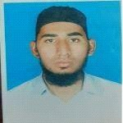 | NAME: | Mr. MOHAMMED AMEENUDDIN
 | DESIGNATION: | ASSISTANT PROFESSOR
 | DATEOFBIRTH | 07-12-1988
 | EDUCATIONAL QUALIFICATION | B.PHARMACY,M.PHARMACY,
 | AREA OF SPECIALIZATION | PHARMACOLOGY
 | WORK/TEACHING EXPERIENCE: | 05 Years
 | NUMBER OF RESEARCH PUBLICATION: | 01
 | NUMBER OF CONFERENCES ATTENDED: | 01

 | NAME: | Ms. TAHMEENA BEGUM
 | DESIGNATION: | ASSOCIATE PROFESSOR
 | DATEOFBIRTH | 18-07-1991
 | EDUCATIONAL QUALIFICATION | B.PHARMACY,M.PHARMACY
 | AREA OF SPECIALIZATION | PHARM-D
 | WORK/TEACHING EXPERIENCE: | 07 Years
 | NUMBER OF RESEARCH PUBLICATION: | 01
 | NUMBER OF CONFERENCESA TTENDED: | 02

 | NAME: | Ms. SRAVANTHI ANANTHULA
 | DESIGNATION: | ASSOCIATE PROFESSOR
 | DATEOFBIRTH | 23-04-1987
 | EDUCATIONAL QUALIFICATION | M.PHARMACY
 | AREA OF SPECIALIZATION | PHARMACEUTICS
 | WORK/TEACHING EXPERIENCE: | 06 Years
 | NUMBER OF RESEARCH PUBLICATION: | 02
 | NUMBER OF CONFERENCES ATTENDED: | 02

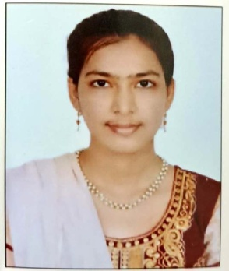 | NAME: | Ms. MUBASHEERA BEGUM
 | DESIGNATION: | ASSISTANT PROFESSOR
 | DATEOFBIRTH | 18/08/1998
 | EDUCATIONAL QUALIFICATION | M.PHARMACY
 | AREA OF SPECIALIZATION | PHARMACOLOGY
 | WORK/TEACHING EXPERIENCE: | 01Year
 | NUMBER OF RESEARCH PUBLICATION: | 01
 | NUMBER OF CONFERENCES ATTENDED: | 01

 | NAME: | Ms. NASREEN SULTANA
 | DESIGNATION: | ASSISTANT PROFESSOR
 | DATEOFBIRTH | 30/10/1996
 | EDUCATIONAL QUALIFICATION | M.PHARMACY
 | AREA OF SPECIALIZATION | PHARMACOLOGY
 | WORK/TEACHING EXPERIENCE: | 03 Year
 | NUMBER OF RESEARCH PUBLICATION: | 01
 | NUMBER OF CONFERENCES ATTENDED: | 01
 | NAME: | Dr. MOHAMMED SALMAN AZAM
 | DESIGNATION: | ASSISTANT PROFESSOR
 | DATEOFBIRTH | 14-03-1985
 | EDUCATIONAL QUALIFICATION | B.PHARMACY,PHARM.D(PB)
 | AREA OF SPECIALIZATION | PHARMACYPRACTICE
 | WORK/TEACHING EXPERIENCE: | 04 YEAR
 | NUMBER OF RESEARCH PUBLICATION: | 03
 | NUMBER OF CONFERENCES ATTENDED: | 02

 | NAME: | Ms.J UMABHARATHI
 | DESIGNATION: | ASSISTANT PROFESSOR
 | DATEOFBIRTH | 29/05/1995
 | EDUCATIONAL QUALIFICATION | B.PHARMACY,M.PHARMACY
 | AREA OF SPECIALIZATION | PHARMACOGNOSY
 | WORK/TEACHING EXPERIENCE: | 02 Year
 | NUMBER OF RESEARCH PUBLICATION: | 01
 | NUMBER OF CONFERENCES ATTENDED: | 02

 | NAME: | Mr. RIZWAN AHMED
 | DESIGNATION: | ASSISTANT PROFESSOR
 | DATEOFBIRTH | 07-01-1991
 | EDUCATIONAL QUALIFICATION | B.PHARMACY,M.PHARMACY
 | AREA OF SPECIALIZATION | PHARMACEUTICS
 | WORK/TEACHING EXPERIENCE: | 02 Year
 | NUMBER OF RESEARCH PUBLICATION: | 01
 | NUMBER OF CONFERENCES ATTENDED: | 02

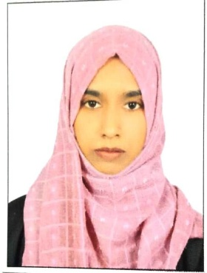 | NAME: | Ms. AMREEN FATIMA
 | DESIGNATION: | ASSISTANT PROFESSOR
 | DATEOFBIRTH | 26/08/1997
 | EDUCATIONAL QUALIFICATION | B.PHARMACY,M.PHARMACY
 | AREA OF SPECIALIZATION | PHARMACEUTICS
 | WORK/TEACHING EXPERIENCE: | 03 Year
 | NUMBER OF RESEARCH PUBLICATION: | 02
 | NUMBER OF CONFERENCES ATTENDED: | 02

 | NAME: | Mr.MD FEROJ BASHA
 | DESIGNATION: | ASSISTANT PROFESSOR
 | DATEOFBIRTH | 20-03-1989
 | EDUCATIONAL QUALIFICATION | B.PHARMACY,M.PHARMACY
 | AREA OF SPECIALIZATION | INDUSTRIALPHARMACY
 | WORK/TEACHING EXPERIENCE: | 02 Year
 | NUMBER OF RESEARCH PUBLICATION: | 02
 | NUMBER OF CONFERENCES ATTENDED: | 03

 | NAME: | Mr. SYED ZUBAIRHUSSAIN
 | DESIGNATION: | ASSISTANT PROFESSOR
 | DATEOFBIRTH | 05/10/1998
 | EDUCATIONAL QUALIFICATION | B.PHARMACY,M.PHARMACY
 | AREA OF SPECIALIZATION | PHARMACEUTICALANALYSIS
 | WORK/TEACHING EXPERIENCE: | 03 Year
 | NUMBER OF RESEARCH PUBLICATION: | 02
 | NUMBER OF CONFERENCES ATTENDED: | 03

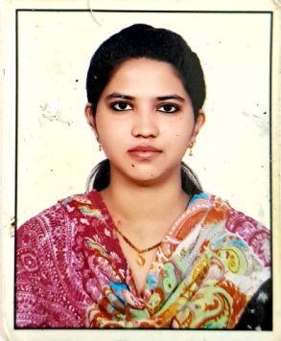 | NAME: | Ms. BATHA JABEEN
 | DESIGNATION: | ASSISTANT PROFESSOR
 | DATEOFBIRTH | 15/03/1989
 | EDUCATIONAL QUALIFICATION | B.PHARMACY,M.PHARMACY
 | AREA OF SPECIALIZATION | PHARMACEUTICS
 | WORK/TEACHING EXPERIENCE: | 04 Years
 | NUMBER OF RESEARCH PUBLICATION: | 03
 | NUMBER OF CONFERENCES ATTENDED: | 05
 | NAME: | Ms. NIZBA BEGUM
 | DESIGNATION: | ASSISTANT PROFESSOR
 | DATEOFBIRTH | 10/04/1999
 | EDUCATIONAL QUALIFICATION | B.PHARMACY,M.PHARMACY
 | AREA OF SPECIALIZATION | PHARMACY PRACTICE
 | WORK/TEACHING EXPERIENCE: | 01 Years
 | NUMBER OF RESEARCH PUBLICATION: | 02
 | NUMBER OF CONFERENCES ATTENDED: | 03

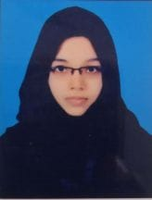 | NAME: | Ms. FATIMA KHATOON
 | DESIGNATION: | ASSISTANT PROFESSOR
 | DATEOFBIRTH | 09/02/1998
 | EDUCATIONAL QUALIFICATION | B.PHARMACY,M.PHARMACY
 | AREA OF SPECIALIZATION | PHARMACEUTICS
 | WORK/TEACHING EXPERIENCE: | 01 Years
 | NUMBER OF RESEARCH PUBLICATION: | 01
 | NUMBER OF CONFERENCES ATTENDED: | 03

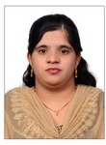 | NAME: | Ms. SAMIYA AFEEN
 | DESIGNATION: | ASSISTANT PROFESSOR
 | DATEOFBIRTH | 10/09/1990
 | EDUCATIONAL QUALIFICATION | B.PHARMACY,M.PHARMACY
 | AREA OF SPECIALIZATION | PHARMACEUTICAL ANALYSIS
 | WORK/TEACHING EXPERIENCE: | 01 Years
 | NUMBER OF RESEARCH PUBLICATION: | 01
 | NUMBER OF CONFERENCES ATTENDED: | 02

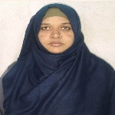 | NAME: | Ms. SHAHEEN BEGUM
 | DESIGNATION: | ASSISTANT PROFESSOR
 | DATEOFBIRTH | 15/08/1996
 | EDUCATIONAL QUALIFICATION | B.PHARMACY,M.PHARMACY
 | AREA OF SPECIALIZATION | PHARMACEUTICAL ANALYSIS
 | WORK/TEACHING EXPERIENCE: | 01 Years
 | NUMBER OF RESEARCH PUBLICATION: | 01
 | NUMBER OF CONFERENCES ATTENDED: | 03

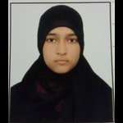 | NAME: | Ms. SHAGUFA NAAZ
 | DESIGNATION: | ASSISTANT PROFESSOR
 | DATEOFBIRTH | 09/07/
 | EDUCATIONAL QUALIFICATION | B.PHARMACY,M.PHARMACY
 | AREA OF SPECIALIZATION | PHARMACEUTICAL ANALYSIS
 | WORK/TEACHING EXPERIENCE: | 01 Years
 | NUMBER OF RESEARCH PUBLICATION: | 01
 | NUMBER OF CONFERENCES ATTENDED: | 03

 | NAME: | Ms. KANKATI SANDHYA MANOHARI
 | DESIGNATION: | ASSISTANT PROFESSOR
 | DATEOFBIRTH | 14/10/1989
 | EDUCATIONAL QUALIFICATION | B.PHARMACY,M.PHARMACY
 | AREA OF SPECIALIZATION | PHARMACEUTICAL TECHNOLOGY
 | WORK/TEACHING EXPERIENCE: | 01 Years
 | NUMBER OF RESEARCH PUBLICATION: | 01
 | NUMBER OF CONFERENCES ATTENDED: | 02

